
COMSATS UNIVERSITY ISLAMABAD(ATTOCK CAMPUS)
NAME: FARYAL BIBI
SP24-BSE-020
LAB MID
INFORMATION SECURITY
Question 1
Caesar Cipher
Write a Python program that encrypts a message using the Caesar Cipher with a user-given shift value.
Example:
Enter message: hello
Enter shift: 3
Ciphertext: khoor

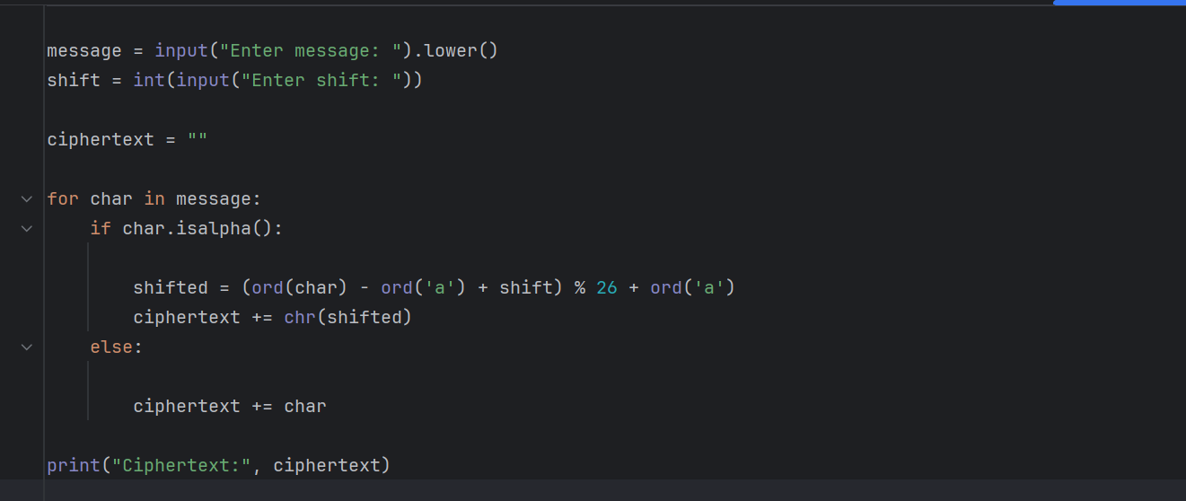

Output:

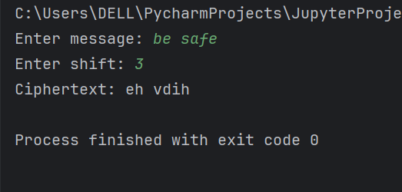

Question 2
Vigenère Cipher (Encryption Only)
Write a Python program to encrypt a plaintext message using the Vigenère Cipher. Ask the user for plaintext and keyword. Display the ciphertext only.
Example:
Enter plaintext: ATTACKATDAWN
Enter key: LEMON
Ciphertext: LXFOPVEFRNHR

Answer:

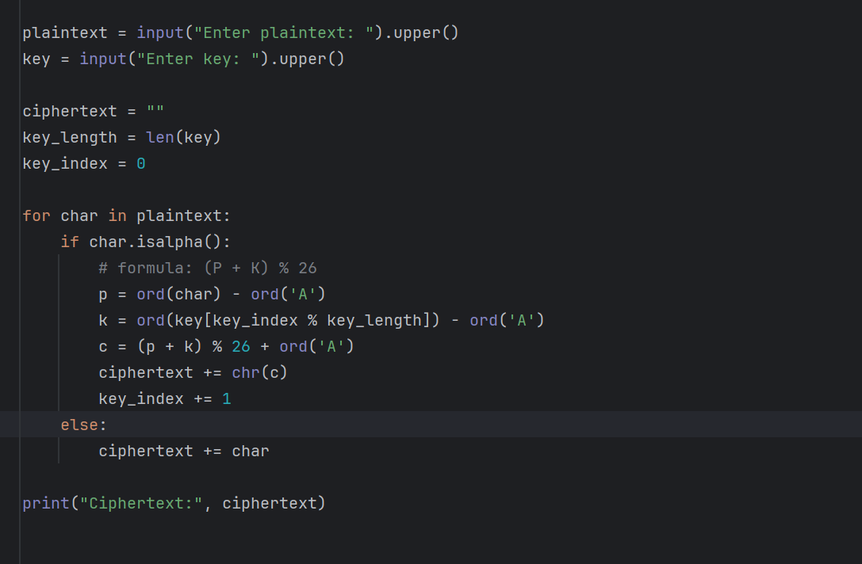

Output:

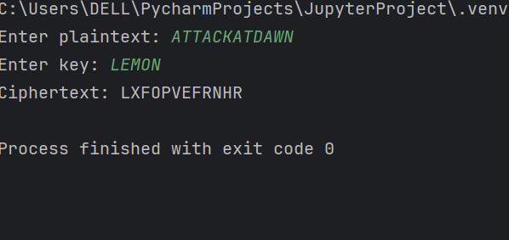

Question 3
Caesar Cipher Decryption (Simple Brute Force) [10 Marks]
You are given a Caesar Cipher ciphertext. Write a Python program to try all 25 possible shift values and print each possible plaintext.
Example Input:
Ciphertext: khoor
Expected Output:
Shift 1: jgnnq
Shift 2: ifmmp
Shift 3: hello <-- correct plaintext

Answer:

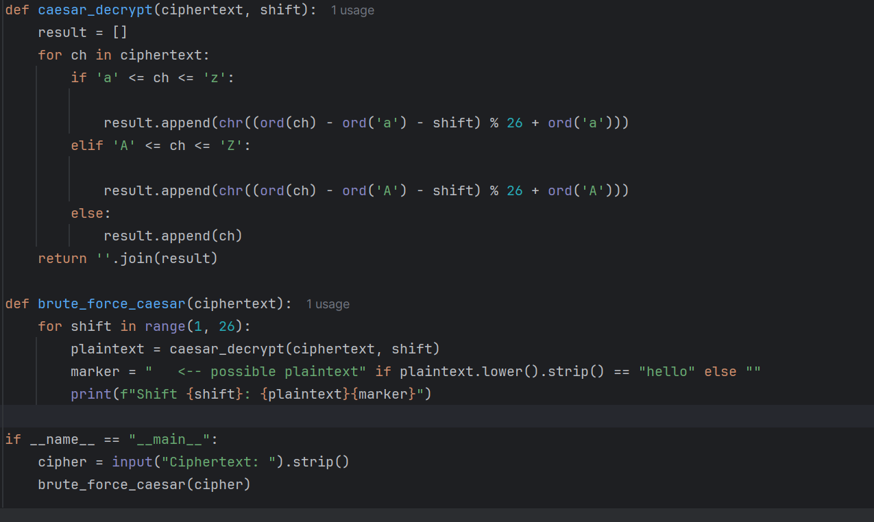

OUTPUT:

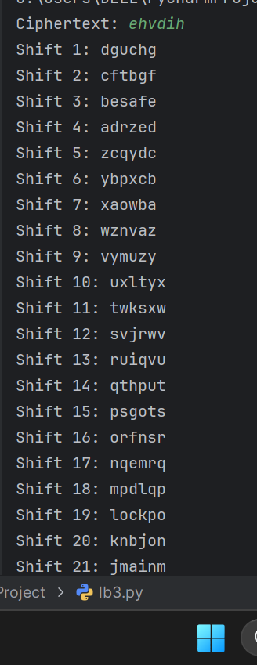

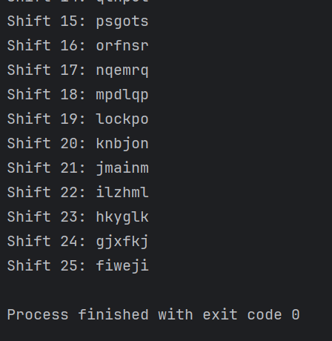

Question 5
DES and AES
a) One difference between DES and AES.
b) AES block size and one key size.
c) One reason why AES is more secure than DES.

Answer:

a) One difference between DES and AES:
DES is a symmetric block cipher that uses a 56-bit key, while AES uses 128, 192, or 256-bit keys for stronger encryption.
b) AES block size and one key size:
AES block size = 128 bits
One key size = 128 bits (can also be 192 or 256 bits)
c) One reason why AES is more secure than DES:
AES has a larger key size, making it much harder to break by brute-force attacks than DES.

